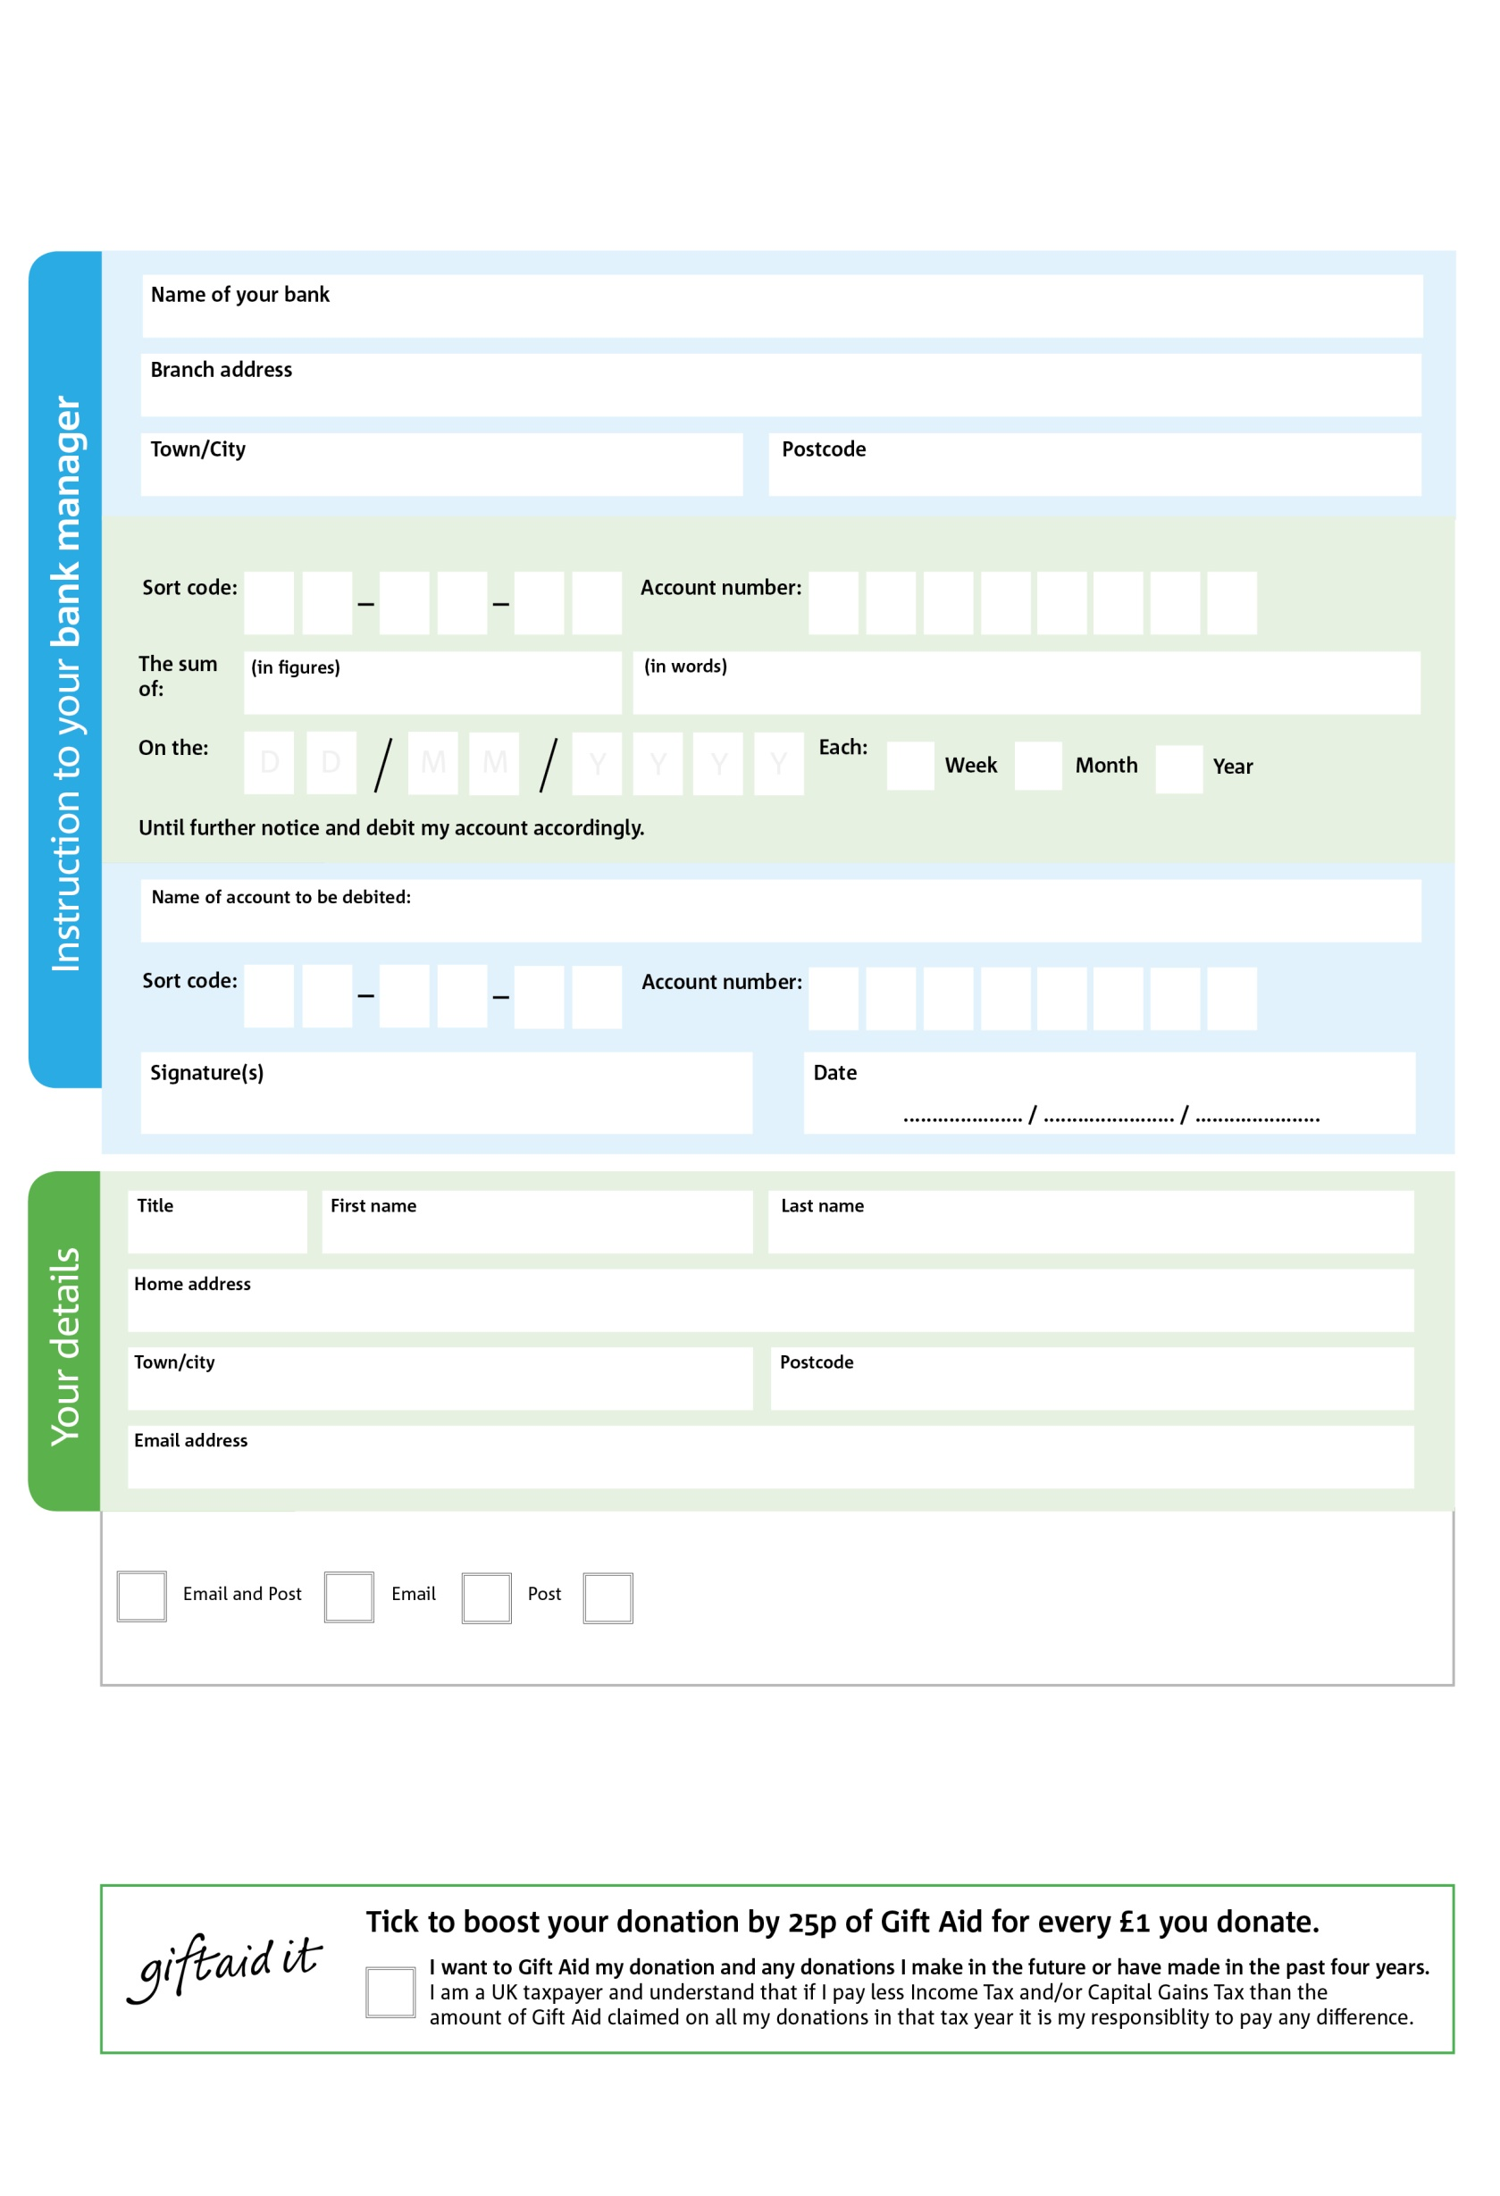

Reg. Charity No: 1119653 | Reg. in England & Wales

**Data protection**

Portsmouth Foodbank is committed to protecting your privacy and will process your personal data in accordance with the Data Protection Act 1998. Portsmouth Foodbank collects information to keep in touch with you and supply you with information relating to our work. Portsmouth Foodbank will never sell or pass your details to anyone who isn’t directly working on our behalf.

POSTAL ADDRESS: Portsmouth Foodbank, King’s Church Hall, Fraser Road, Southsea, PO5 1EE

6

V

4

V

7

V

1

V

2

V

0

V

0

V

0

V

**Please pass this form onto the foodbank, using the foodbank’s address at the bottom, who will save a copy for their records. They will then send it onto your named bank or building society.**

0

4

2

5

0

4

We would love to keep you up to date with information about Portsmouth Foodbank. Please tick your preference:

You can change your preferences any time by contacting us on 023 9298 7976 or emailing us at foodbank@kingschurchportsmouth.co.uk

I do not wish to receive future communications from Portsmouth Foodbank

Please pay Portsmouth Foodbank,

**Standing Order Mandate**

**portsmouth.foodbank.org.uk**

You can change your preferences any time by contacting us on XXXXXXXXXXX or emailing us at XXXX@XXXXXXXXXX.foodbank.org.uk

I do not wish to receive future communications from XXXXXX Foodbank